
ROAD SAFETY
DOMINOS

Road Safety Team
Print & cut out the dominos or create a bright set at home.
Play a fun game whilst using the helpful facts to learn about road safety.

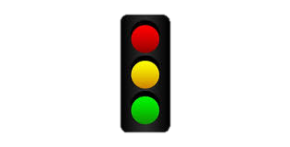
Traffic Lights
Traffic Lights
Traffic Lights
Traffic Lights
Traffic Lights

Zebra Crossing
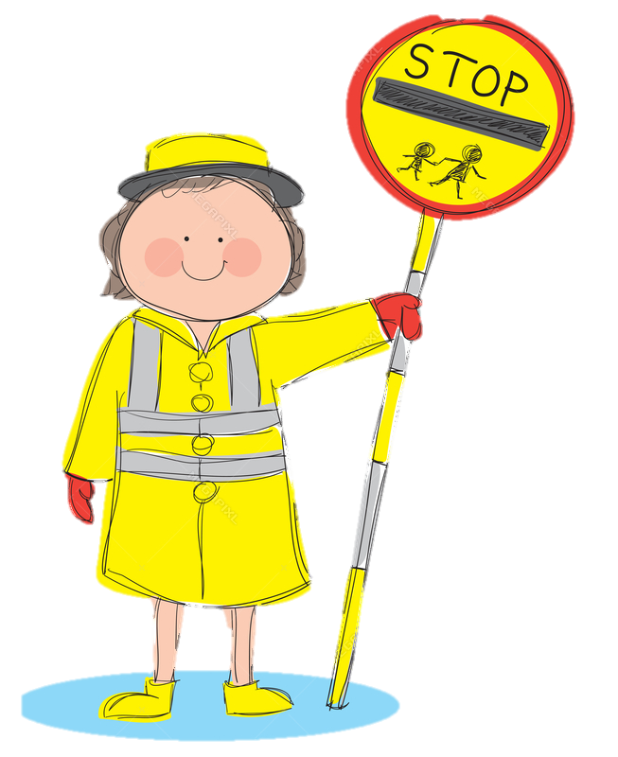
Lollypop Person

Lollypop Person

Scooter

Bicycle

Shared Path Sign
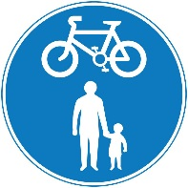
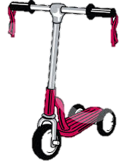
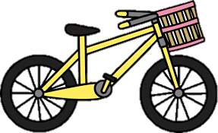
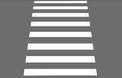

Scooter

Scooter

Scooter
Traffic Lights
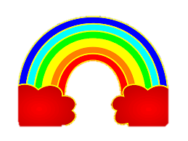
Rainbow Drawing

Scooter

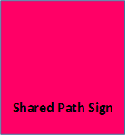

Bicycle

Zebra Crossing
Traffic Lights
Traffic Lights

Rainbow Drawing

Scooter

Zebra Crossing
Rainbow Drawing

Scooter
Lollypop Person

Lollypop Person

Scooter

Scooter

Rainbow Drawing

Zebra Crossing

Rainbow Drawing
Lollypop Person

Lollypop Person
Rainbow Drawing
Rainbow Drawing
Rainbow Drawing

Zebra Crossing

Bicycle
Lollypop Person

Lollypop Person

Bicycle

Zebra Crossing

Zebra Crossing

Zebra Crossing
Lollypop Person

Lollypop Person

Bicycle
Helpful Facts
Lollypop person – Helps you to cross the road outside of a school, always remember to wait on the pavement while the lollypop person stops all the traffic and do not cross until told it is safe to do so. Remember to walk in front of the lollypop person so they can see you and keep you safe. Don’t forget to dismount your bike or scooter.
Zebra Crossing – Traffic should stop for all pedestrians waiting to cross at a zebra crossing but always make sure all traffic has stopped before you cross. A zebra crossing is made up of white strips painted on the road that are like the white strips on a zebra. You will always find two flashing yellow lights at the top of stripy poles either side of a zebra crossing, these are called Belisha beacons.
Traffic Lights – All drivers must follow the rules of a traffic light. When a driver sees a red traffic light they must stop. When a driver sees a green light they may go if it is safe. When a driver sees an amber light they should stop if it is safe to do so.
Bicycle & Scooter – A handy way to get around. Always check your cycle or scooter before setting off. The ‘ABC check’ is always handy, A-check the AIR in your tyres, B-check your BRAKES, C-check your CHAIN. Remember to be cautious when travelling on the pavement there maybe others using the paths. And always wear your helmet.
Shared Path Sign – This sign can be found on a pavement where cyclists and pedestrians share the pathway. Remember to use your bell to let others know you are approaching.
Rainbow Drawing – These can be found all over the UK to thank our key workers for all their hard work. You may have designed one yourself or seen lots of designs when out and about doing your daily exercise.

Bicycle
Lollypop Person

Lollypop Person
Lollypop Person

Lollypop Person
Lollypop Person

Lollypop Person

Bicycle

Bicycle

