
OUT & ABOUT
SCAVENGER HUT
Road Safety Team
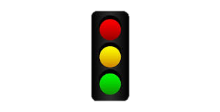
Traffic Lights

Red Car
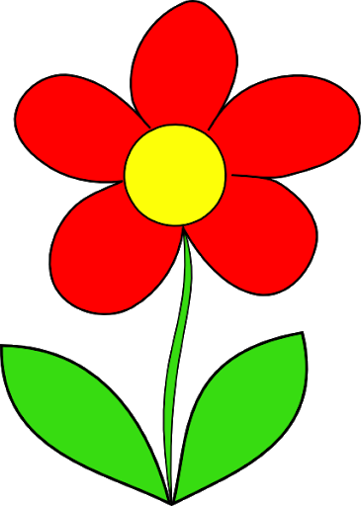
Flower

Road sign. Draw the sign you see
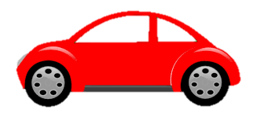

Zebra Crossing

Rainbow Drawing
Dra

R

Shared Path Sign

Bird
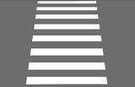
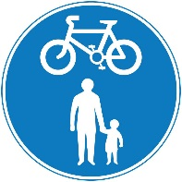
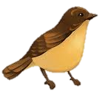
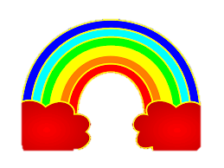

Roundabout
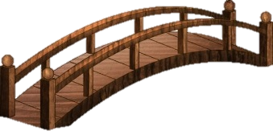
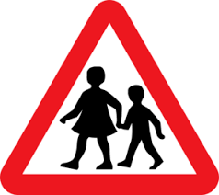
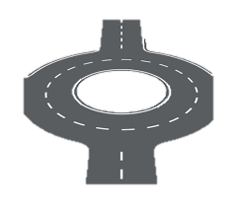

Bridge

School Sign

Bicycle
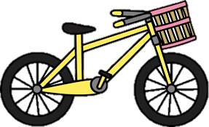

Dog

Scooter

Van

Tree
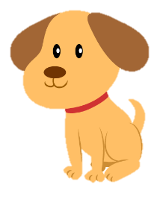
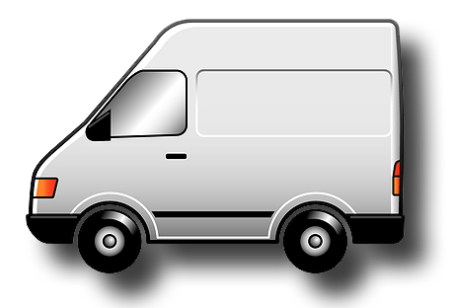
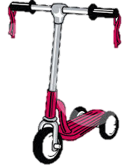
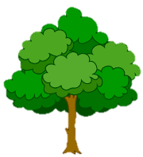

The Green Cross Code Fill in the gaps using the words below
Find a _____ place to cross. Stop just before you get to the _____. Look all around for_________ and listen. If traffic is coming ________________. When it is safe, go_________ across the road.
Do not run, keep ___________ and __________ as you cross.
Looking Straight Kerb Traffic Safe Listening Let it pass

