SJM Number Clubs
Yr group  objective | Number Club | Time | Learning Objective
Y1 | More or Less than Club | 3 mins | Say a number that is one more or less than a number from 10 to 20
 | Making 10 Club | 3 mins | Know by heart all pairs of numbers that make 10
 | 15 Club | 3 mins | Add and subtract two numbers under 10
 | Counting in multiples Club | 3 mins | Count in multiples of 2, 5 and 10
 | 20 Addition Club | 3 mins | Add two numbers under 20
Y2 | 25 Subtraction Club | 3 mins | Subtract two numbers under 20
 | Making 100 Club | 3 mins | Know pairs of ‘tens’ numbers that make 100
 | Doubling & Halving Club | 3 mins | Double and halve small numbers
 | 30 Addition & Subtraction Club | 3 mins | Know by heart addition and subtract facts to 20
 | 35 Club | 3 mins | Know by heart 2x and 10x table
 | 40 Club | 3 mins | Know by heart 2x, 5x and 10x table

Name………………………………………………….

More or Less than Club up to 20

1 less than 8 = 1 more than 5 = 1 less than 9 =

1 less than 5 = 1 more than 4 = 1 more than 7 =

1 less than 3 = 1 less than 6 = 1 less than 2 =

1 more than 18 = 1 more than 15 = 1 more than 19 =

1 less than 15 = 1 more than 14 = 1 less than 17 =

1 less than 3 = 1 less than 6 = 1 less than 2 =

1 more than 5 = 1 less than 4 = 1 less than 7 =

1 less than 13 = 1 less than 16 = 1 less than 12 =

1 less than 18 = 1 less than 15 = 1 less than 19 =

1 more than 15 = 1 less than 14 = 1 more than 17 =

Name………………………………………………….

Making 10 Club

7 + = 10 3 + = 10 6+ = 10

5 + = 10 2 + 2 = 10 1+ = 10

4 + = 10 8 + = 10 7+ = 10

9 + = 10 6 + = 10 5+ = 10

5 + 4 = 10 + 2 = 10 1+ = 10

5 + = 10 4 + = 10 3+ = 10

2 + = 10 + 1 = 10

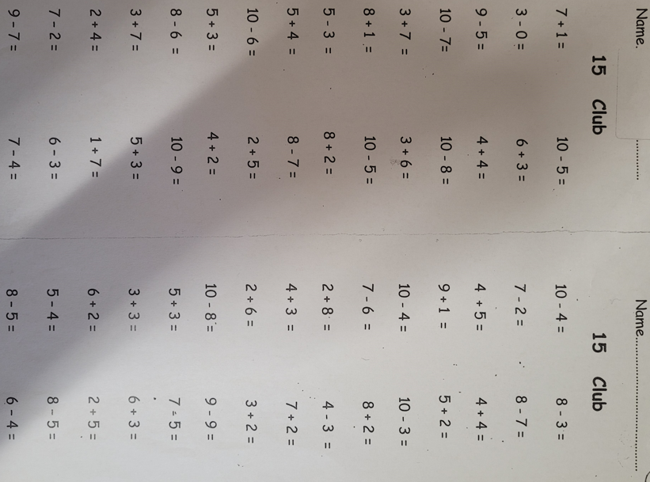

Name………………………………………………….

Counting in Multiples

1 x 10=  2 x 10=  3 x 10=  4 x 10=  5 x 10=  6 x 10=  7 x 10=  8 x 10=  9 x 10=  10 x 10= | 1 x 2=  2 x 2=  3 x 2=  4 x 2=  5 x 2=  6 x 2=  7 x 2=  8 x 2=  9 x 2=  10 x 2= | 1 x 5=  2 x 5=  3 x 5=  4 x 5=  5 x 5=  6 x 5=  7 x 5=  8 x 5=  9 x 5=  10 x 5=

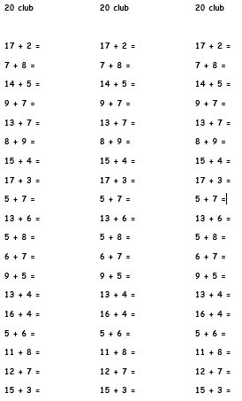

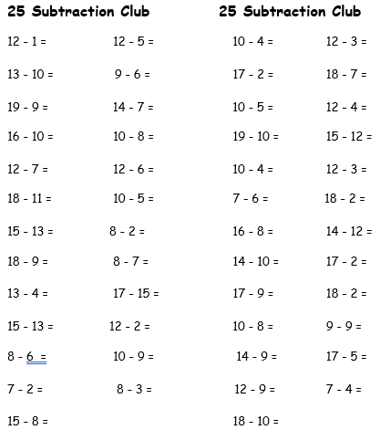

Making 100 Club

70 + = 100 30 + = 100 60 + = 100

50 + = 100 + 20 = 100 10 + = 100

40 + = 100 80 + = 100 70 + = 100

90 + = 100 60 + = 100 50 + = 100

5 + 40 = 100 + 20 = 100 10 + = 100

50 + = 100 40 + = 100 30+ = 100

20 + = 100 + 10 = 100

Score = ____
20



